Test Case: tc003_SPX_Dev5_Crear_Requisicion_Spot_Tipo_Cobro_CC_Urgent
Step 1 - Enter username and password and click to button Enter : Credentials Entered
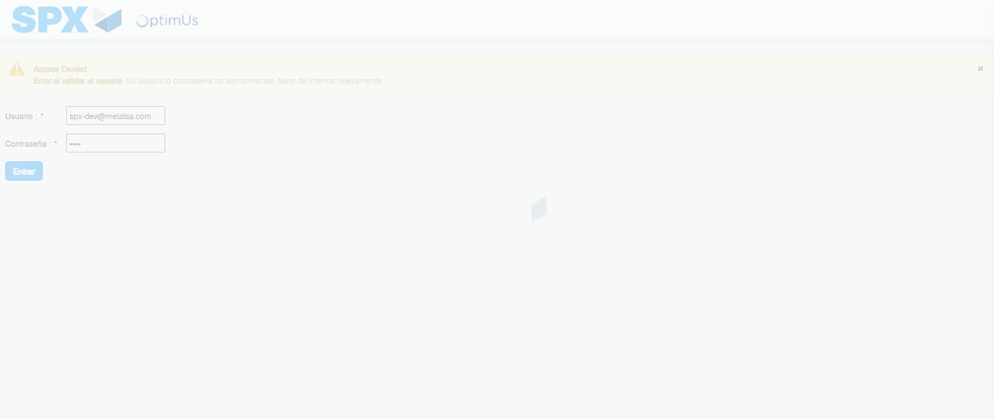Image file-name: QC_Testing-tc003_SPX_Dev5_Crear_Requisicion_Spot_Tipo_Cobro_CC_Urgent-1785959925590

Step 2 - Select to UEN and Access to Spot Buy Requisitions : UEN Correctly selected and Correct access
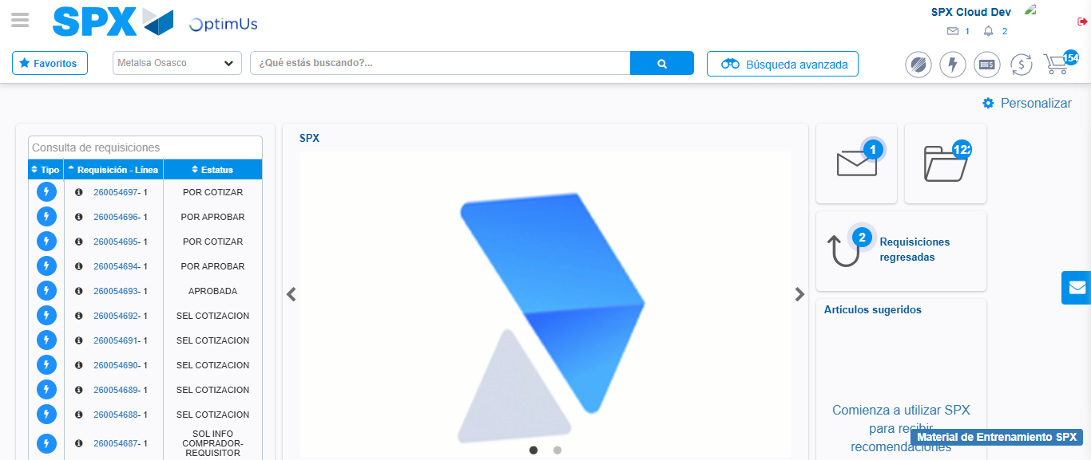Image file-name: QC_Testing-tc003_SPX_Dev5_Crear_Requisicion_Spot_Tipo_Cobro_CC_Urgent-1785959991074

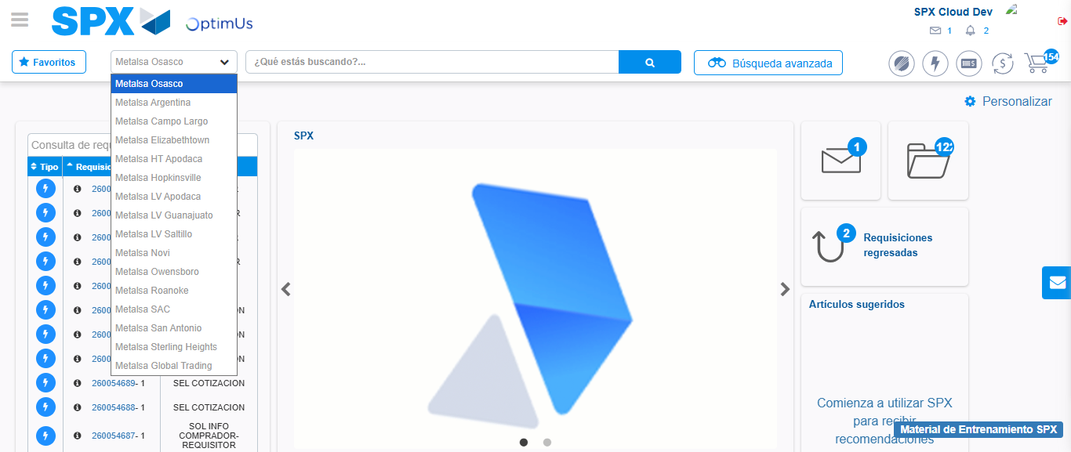Image file-name: QC_Testing-tc003_SPX_Dev5_Crear_Requisicion_Spot_Tipo_Cobro_CC_Urgent-1785959993656

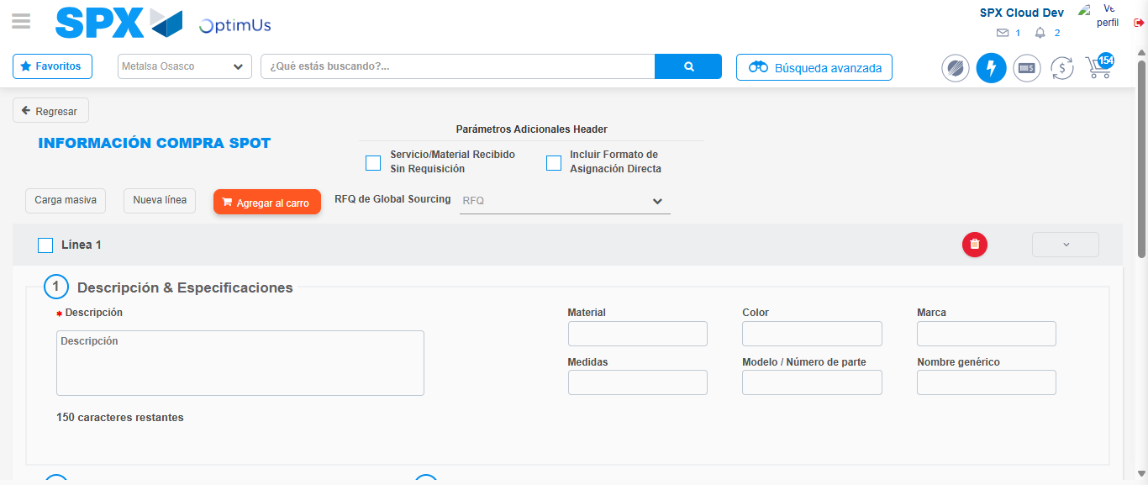Image file-name: QC_Testing-tc003_SPX_Dev5_Crear_Requisicion_Spot_Tipo_Cobro_CC_Urgent-1785960017070

Step 3 - Data Capture Spot Buy Requisition: Data captured correctly
Image file-name: QC_Testing-tc003_SPX_Dev5_Crear_Requisicion_Spot_Tipo_Cobro_CC_Urgent-1785960017308

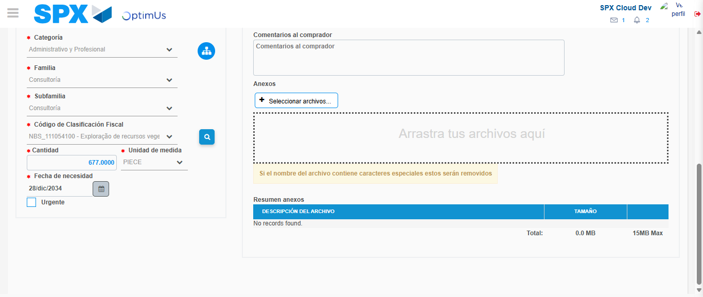Image file-name: QC_Testing-tc003_SPX_Dev5_Crear_Requisicion_Spot_Tipo_Cobro_CC_Urgent-1785960081922

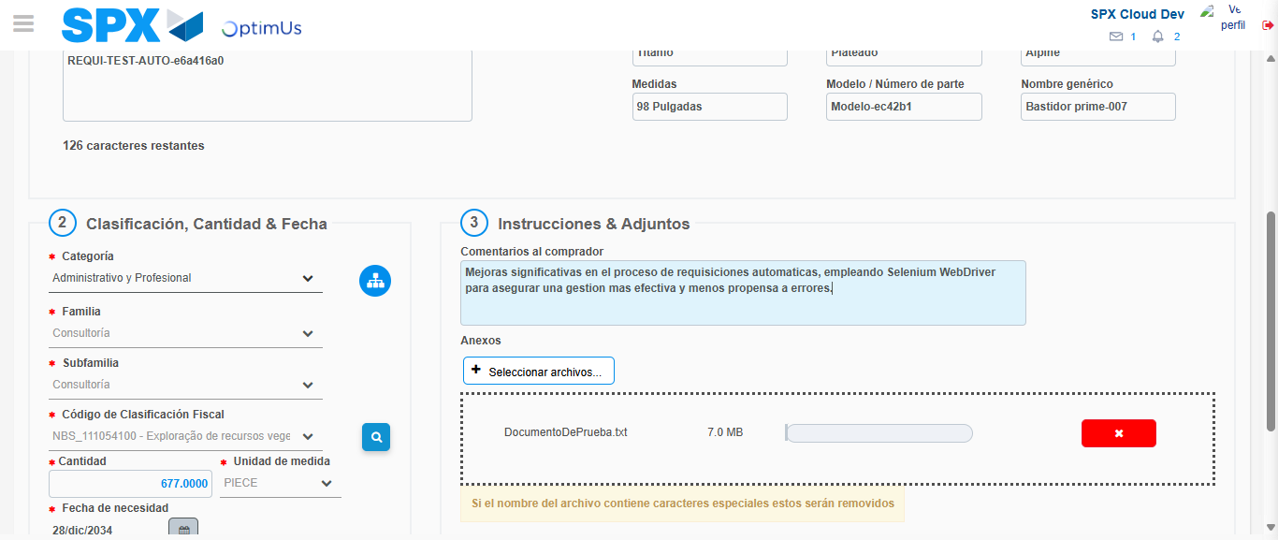Image file-name: QC_Testing-tc003_SPX_Dev5_Crear_Requisicion_Spot_Tipo_Cobro_CC_Urgent-1785960082690

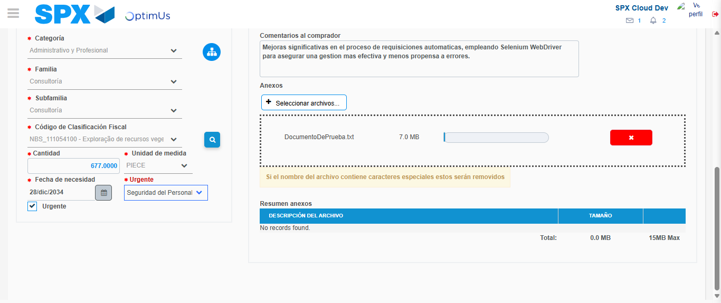Image file-name: QC_Testing-tc003_SPX_Dev5_Crear_Requisicion_Spot_Tipo_Cobro_CC_Urgent-1785960090455

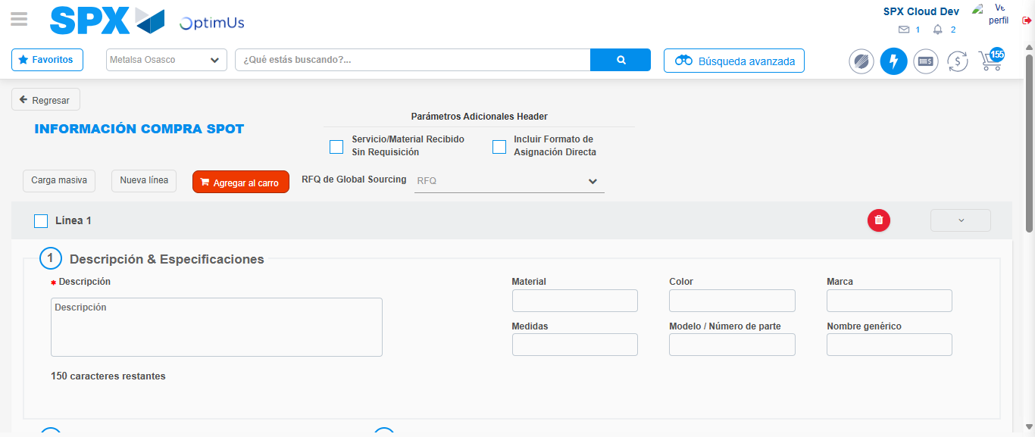Image file-name: QC_Testing-tc003_SPX_Dev5_Crear_Requisicion_Spot_Tipo_Cobro_CC_Urgent-1785960110280

Step 7 - Return to Main Page SPX : Return to Main Page SPX
Image file-name: QC_Testing-tc003_SPX_Dev5_Crear_Requisicion_Spot_Tipo_Cobro_CC_Urgent-1785959991074

Image file-name: QC_Testing-tc003_SPX_Dev5_Crear_Requisicion_Spot_Tipo_Cobro_CC_Urgent-1785959993656

Image file-name: QC_Testing-tc003_SPX_Dev5_Crear_Requisicion_Spot_Tipo_Cobro_CC_Urgent-1785960017070

Image file-name: QC_Testing-tc003_SPX_Dev5_Crear_Requisicion_Spot_Tipo_Cobro_CC_Urgent-1785960112518

Image file-name: QC_Testing-tc003_SPX_Dev5_Crear_Requisicion_Spot_Tipo_Cobro_CC_Urgent-1785960112687

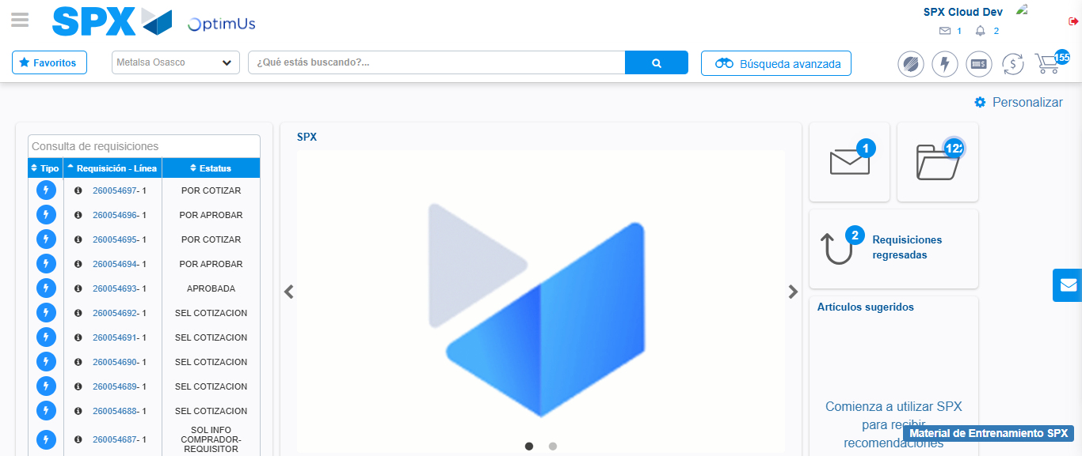Image file-name: QC_Testing-tc003_SPX_Dev5_Crear_Requisicion_Spot_Tipo_Cobro_CC_Urgent-1785960133670

Step 8 - Log Out : Log Out SPX
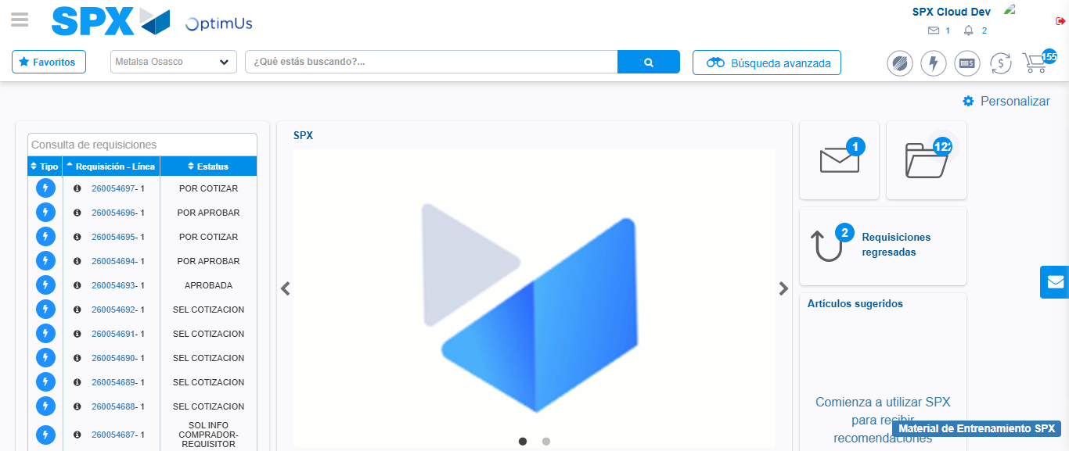Image file-name: QC_Testing-tc003_SPX_Dev5_Crear_Requisicion_Spot_Tipo_Cobro_CC_Urgent-1785960133981

